A SAINT FOR THIS WEEK

Thursday 22nd October St John Paul II (1920-2005)

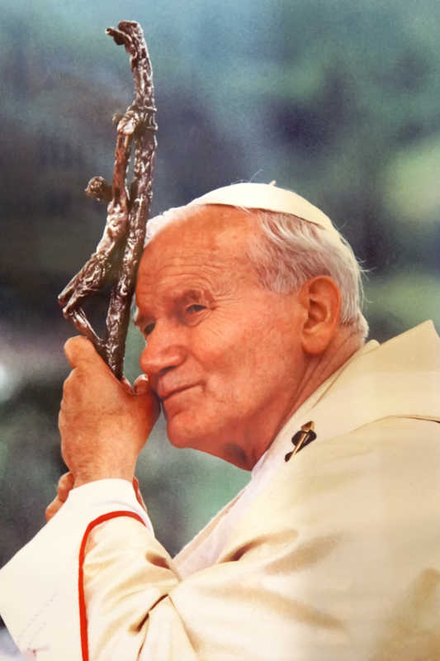

Karol Józef Wojtyła was born in 1920 in Wadowice, Poland. After his ordination to the priesthood and theological studies in Rome, he returned to his homeland and resumed various pastoral and academic tasks. He became first auxiliary bishop and, in 1964, Archbishop of Kraków and took part in the Second Vatican Council. On 16th October 1978 he was elected pope and took the name John Paul II. His exceptional apostolic zeal, particularly for families, young people and the sick, led him to numerous pastoral visits throughout the world. Among the many fruits which he has left as a heritage to the Church are above all his rich Magisterium and the promulgation of the Catechism of the Catholic Church as well as the Code of Canon Law for the Latin Church and for the Eastern Churches. In Rome on 2nd April 2005, the eve of the Second Sunday of Easter (or Divine Mercy Sunday), he died peacefully in the Lord after a long period of illness. He was canonized by Pope Francis on 27th April, the Second Sunday of Easter 2014. He was the first Bishop of Rome to visit the United Kingdom, which visit included a memorable service of Unity in Canterbury Cathedral, and it was during his pontificate that some of the most important documents from the Anglican/Roman Catholic International Commission were produced. His many encyclicals, including Veritatis Splendor (The Splendour of Truth) and Fides et Ratio (Faith and Reason) are as relevant today as they were when first issued. Pray particularly on his feast day for the Unity of the Church.

